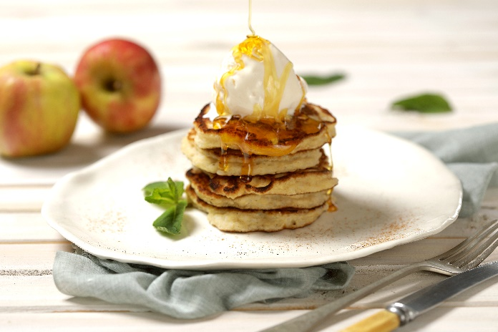

Rice flap jacks with apple and cinnamon
Makes: 12 - 16
Prep time: 10 minutes
Cooking time: 20 minutes

Ingredients:
750ml (3 cups) leftover or cooked Golden Delight Long Grain White Parboiled Thai Rice
½ 410g tin pie apple
375ml (1 ½ cups) flour
60ml (4 tablespoons) brown sugar
10ml (2 teaspoons) ground cinnamon
2 extra large eggs
10ml (2 teaspoons) baking powder

Method:
- Place all the ingredients in a large bowl and blitz with a stick blender until 80% smooth.
- Spray a pan with cooking spray, and place on medium heat, with 15ml (1 TBSP) cooking oil.
- Drop spoonsful of batter into the pan, ensuring that they do not flow into each other. When the mixture starts to bubble on top, turn the flap jacks over, using a spatula, and allow to cook until golden brown and done.
- Serve with cream or ice cream and syrup.

Tip:
- For berry flapjacks, replace the apple and cinnamon with 125ml (1/2 cup) fresh or frozen berries of choice, and an additional 45ml (3 TBSP) flour. Serve with berry coulis and fresh berries.
- For banana chocolate flapjacks, replace the apple with 1 ripe banana and 60ml (4 TBSP) grated chocolate.

